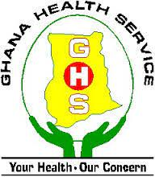
NUTRITION-ORIENTED INTERVENTIONS
1. Early breast milk initiation within the first 30 minutes of life
2.Exclusive breastfeeding
3. Maternal infant and young child nutrition
4. Girls Iron Folate Tablet Supplementation
5. Vitamin A supplementation in children under 5
6. Community based Management of Acute Malnutrition
7. Social and Behavior Change Communication (SBCC) activities on school-based
nutrition services (NFSI)
8. Growth monitoring and promotion
9. Nutrition Day Care surveillance
10. Deworming in children under 5
11. Iodated salt survey
12. Nutrition assessment and counselling for patients with TB
13. Nutrition education for the prevention of non-communicable diseases
14. Measles
15. Anaemia prevention among pregnant women
16. Integrated Social Services

For more information contact 0200165129

